ASSIGNMENT 1

Study of Ubuntu OS:
Introduction to Linux and Ubuntu
Linux is an open-source operating system kernel, developed by Linus Torvalds in 1991. Unlike proprietary operating systems such as Windows or macOS, Linux is distributed under the GNU General Public License (GPL), which means that anyone can freely use, modify, and distribute it. Over the years, many distributions (distros) have been built on the Linux kernel, offering different features and interfaces tailored to specific user needs. Examples of popular Linux distros include Debian, Fedora, CentOS, and Ubuntu.
Ubuntu is a Linux-based operating system developed and maintained by Canonical Ltd. The first version of Ubuntu was released in 2004, with a focus on ease of use, a modern user interface, and compatibility with a wide range of hardware. Ubuntu is one of the most popular Linux distributions and is known for its stability, security, and simplicity, making it an excellent choice for beginners.
Ubuntu Versions:
Ubuntu releases a new version every six months, and each version has a codename, typically based on an adjective and an animal (e.g., “Bionic Beaver” for Ubuntu 18.04).
LTS (Long Term Support) versions are released every two years and receive updates for 5 years. These versions are often preferred for production environments and servers due to their stability.
The current stable version as of 2025 is Ubuntu 24.04 LTS.
History of Ubuntu: Ubuntu was created by Mark Shuttleworth and his company Canonical Ltd. in 2004. The name "Ubuntu" is derived from an African philosophy meaning "humanity to others," reflecting the project's focus on making Linux accessible to everyone. Ubuntu has become one of the most widely used Linux distributions due to its focus on usability, hardware compatibility, and regular release cycles.
Features of Ubuntu
User-Friendly Interface: Ubuntu uses the GNOME desktop environment by default, providing a clean and intuitive interface suitable for both beginners and advanced users.
Free and Open Source: Ubuntu is free to download, use, and modify, making it an attractive option for users and developers alike.
Software Center: Ubuntu comes with a built-in Software Center that makes it easy to find and install applications with just a few clicks.
Security: Ubuntu is known for its security features, including regular security updates, a firewall, and access controls (AppArmor). The sudo command also adds an additional layer of security for system administration tasks.
Software Updates: Ubuntu regularly releases software and security updates, ensuring that the system remains up to date with the latest features and patches.
Support for Multiple Architectures: Ubuntu supports a wide range of hardware architectures, including x86, ARM, and PowerPC.
Community Support: Ubuntu has an active and large community that offers a wealth of tutorials, forums, and online resources to assist users.
Customization: Ubuntu is highly customizable, allowing users to tweak almost every aspect of the operating system, from themes to system settings.
Package Management: Ubuntu uses the APT (Advanced Package Tool) system for installing, updating, and removing software. Packages are downloaded from a central repository, ensuring consistency and security.
Installing of Virtual Box:

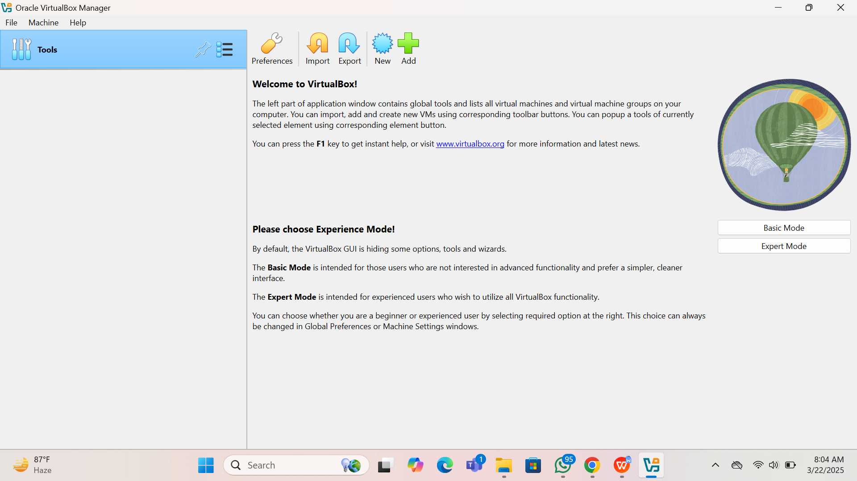

Difference Between Ubuntu and Windows OS
Feature | Ubuntu (Linux) | Windows OS
User Interface | GNOME desktop environment (default) | Windows desktop with Taskbar, Start menu, and File Explorer
Cost | Free, open-source | Paid, requires a license
Source Code | Open-source (anyone can modify) | Closed-source (proprietary)
Security | Built-in firewall, regular security updates | Regular updates, but less secure than Linux by default
Performance | Generally faster, especially on older hardware | Can be resource-heavy, especially with newer versions
Customization | Highly customizable | Limited customization options for users
Software Availability | Software available via APT or Software Center | Wide variety of commercial and third-party software
System Resource Usage | Lightweight, low system resource usage | Requires more resources, especially with newer versions
Virus/Malware Protection | Less vulnerable to viruses and malware | More vulnerable to viruses, requires antivirus software
System Administration | Command-line interface, terminal-based | Graphical User Interface (GUI)-based, easier for beginners
Software Installation | Uses package managers (APT) for software | Software is installed via .exe or .msi files
Popularity | Popular among developers and technical users | Dominates the personal desktop market globally

Conclusion Ubuntu is a highly versatile and user-friendly Linux distribution, offering significant advantages over Windows in terms of security, performance, and cost. It is particularly favored for its ease of use, large community support, and customization capabilities. While Windows remains the dominant operating system in the personal computing space, Ubuntu is a compelling choice for users looking to explore Linux or those seeking an alternative OS for security and performance reasons.

